Let X be a Gaussian random variable with mean 10 and variance 4. A sample of size 9 is obtained and the sample mean is calculated. Find the probability that the sample mean is less than 9.
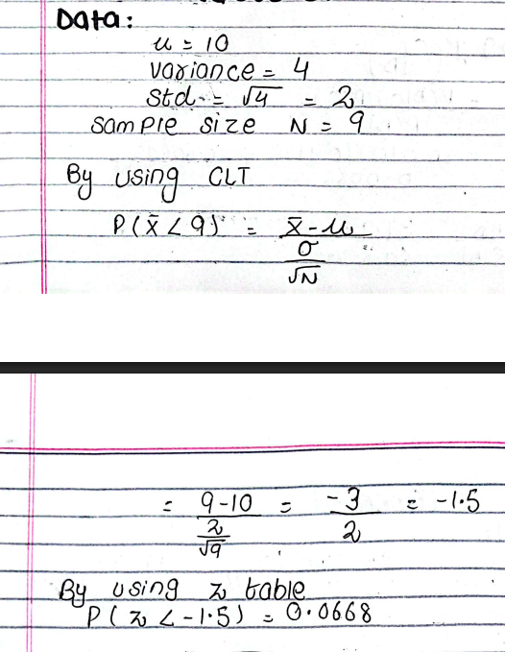

The lifetime of a cheap light bulb is an exponential random variable with mean 36 hours. Suppose that 16 light bulbs are tested and their lifetimes measured. Use the central limit theorem to estimate the probability that the sum of the lifetimes is less than 600 hours.
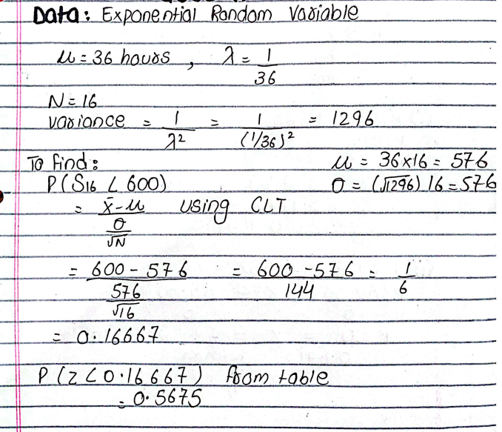

A fair coin is tossed 100 times. By using the Central Limit Theorem, estimate the probability that the number of heads is between 40 and 60. Estimate the probability that the number is between 50 and 55.
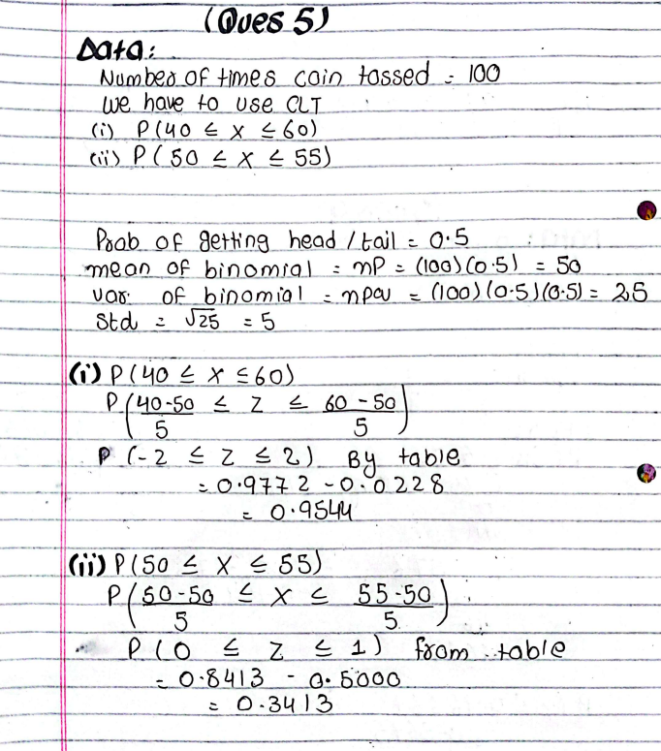

Suppose that orders at a restaurant are IID random variables with mean μ=$8 and standard deviation σ=$2.
Answer the following:
a. Estimate the probability that the first 100 customers will spend a total of between $780 and $820.
b. After how many orders can we be 90% sure that the total spent by all customers is more than $1000?
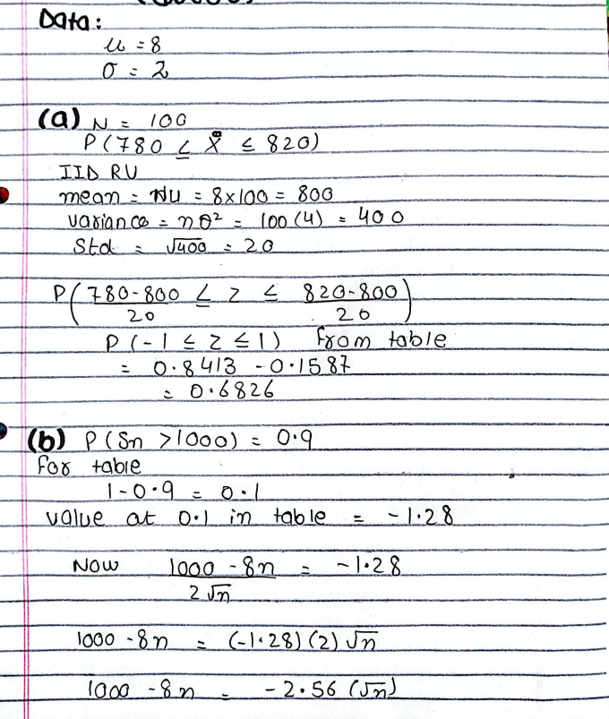

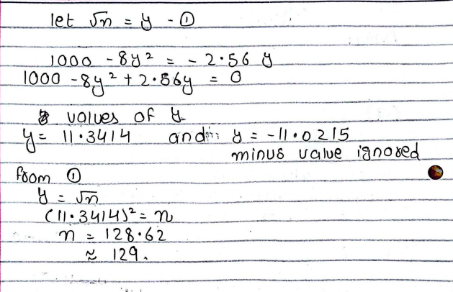
2. Passengers arrive at a taxi stand at an airport at a rate of one passenger per minute. The taxi driver will not leave until seven passengers arrive to fill his van. Suppose that passenger inter-arrival times are exponential random variables, and let X be the time to fill a van. Find the probability that more than 10 minutes will elapse until the van is full.
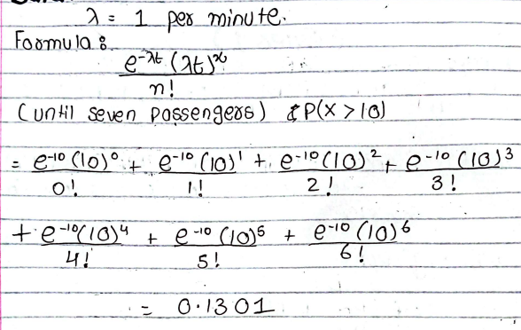

A computer manufacturer uses chips from three sources. Chips from sources A, B, and C are defective with
probabilities 0.005, 0.001, and 0.010, respectively. If a randomly selected chip is found to be defective, find
the probability that the manufacturer was A; that the manufacturer was C.
